**Install Guide**

**1. Run "Git-1.7.11-preview20120704.exe" to install msysgit**

**2. Run "KDiff3Setup_0.9.96.exe" to install tool for merging and comparing**

**3. Run "nGitSetup.msi" to install NGit**

**4. Open VS to configure the Ngit.**

4.1 Open menu item “Tools\Options\Source Control”, then select Ngit, just as followed.

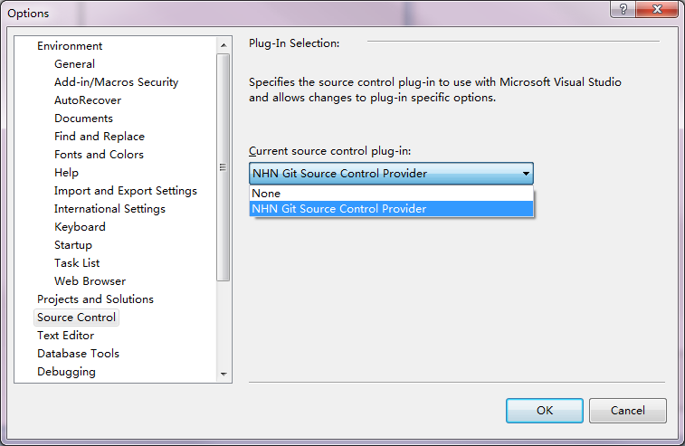

4.2 Configure the working options in the property window.

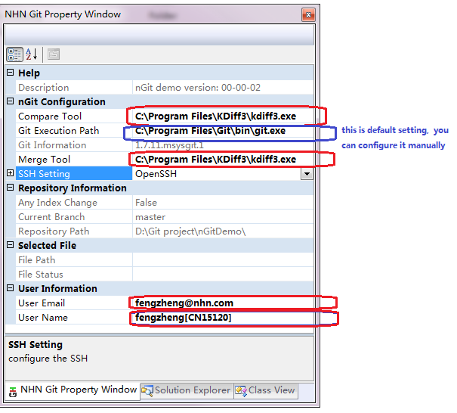

4.3 Right click the VS Frame, and select NGit Item from context menu to show toolbar..





**5. VS working status jus as followed**

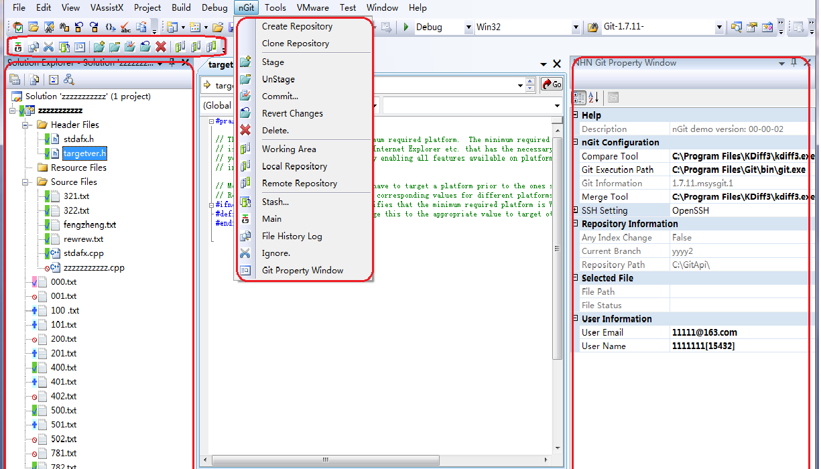

**6. Main Function points**

